**Terraform Day-05**

***Mohammed Rafiyoodin – 29-8-05-2024***

Terraform(statelocks,creation of s3,dynamolock table, tf provisinores,and commands)

1. Watch terraform-05 video.
2. Execute the script shown in video.
3. Create one ec2 instance with httpd installed using terraform script.
4. Setup s3 as backend to the task 3.
5. Setup dynamo db locking for task3.

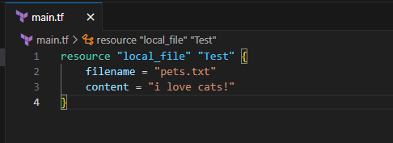

Terraform init

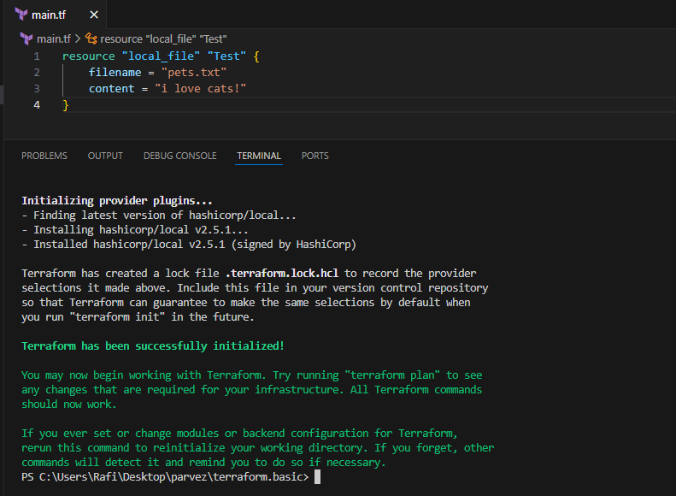

Terrafrom apply

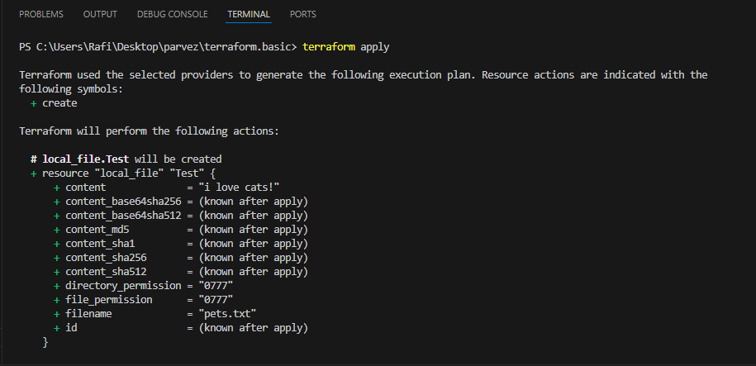

Terraform Remote state and state locking:

=========================================

We can store terraform configuration files and state file in github or any other repository but it is not good practise.

We use s3,terraform storage,hashicorp consul to store the state file.

State locking is used to lock the state file so that no two users can execute the state file at the same point of time.

Remote backend and state locking:

================================

We can use s3 as remote backend and dynamo db for state locking.

Terrafrom destroy

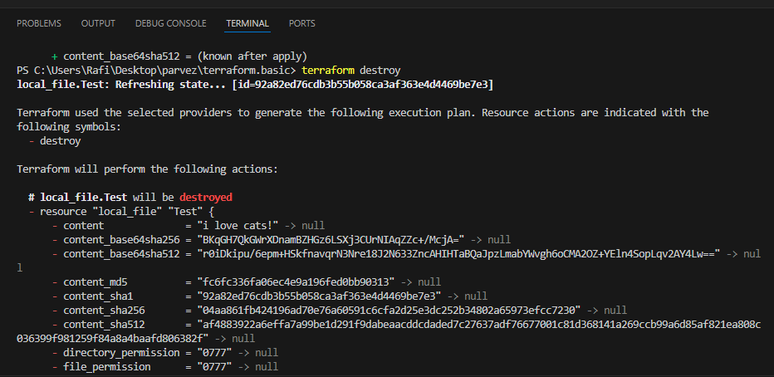

Create s3 using terraform:

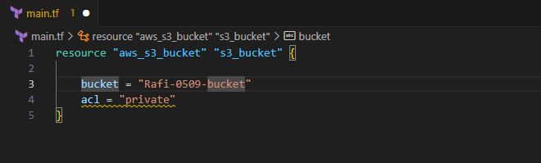

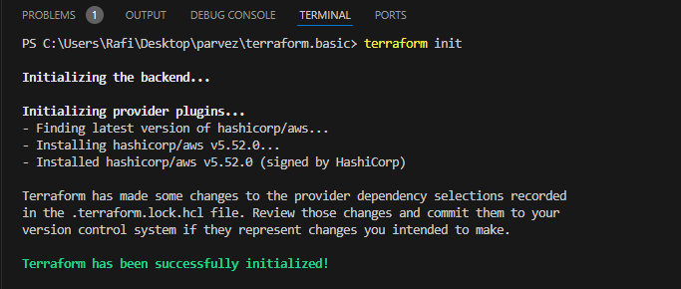

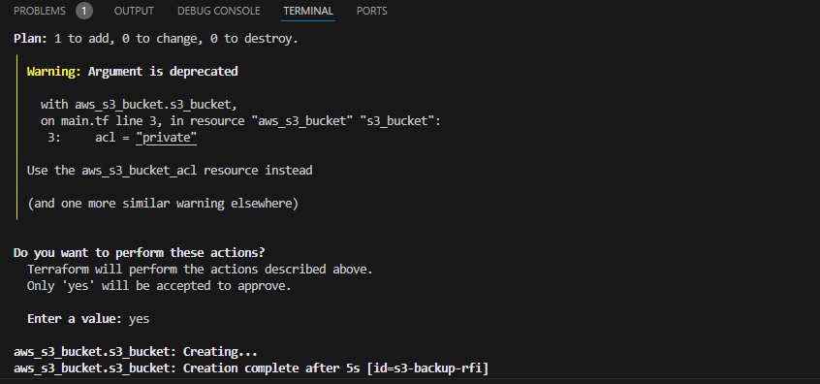

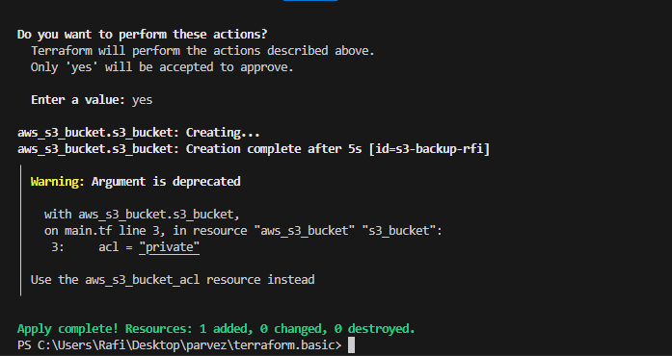

Go to AWS s3

Check the bucket

Created S3 bucket

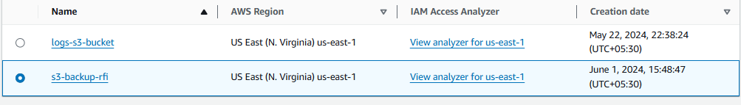

Create dynamo db using terraform:

================================

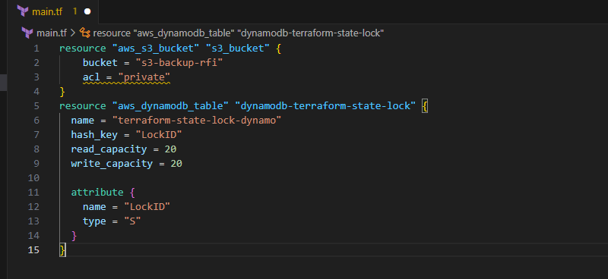

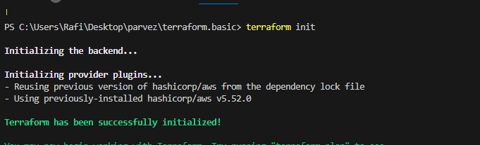

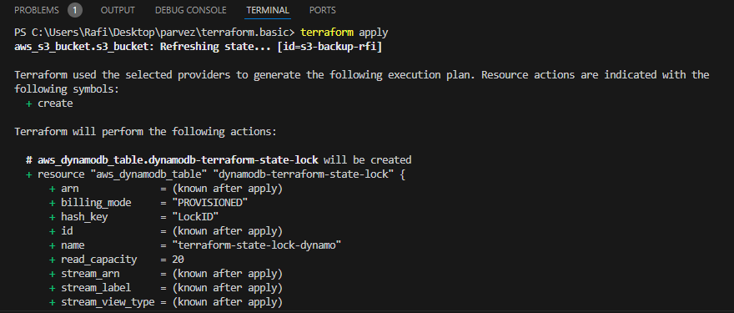

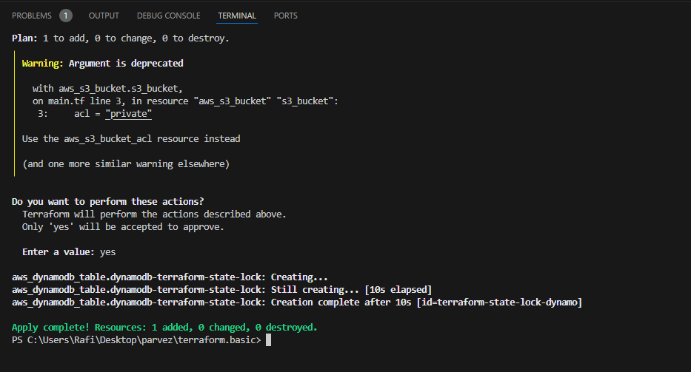

Go to Dynamo DB in AWS service

Check Dynamo DB created

Check table

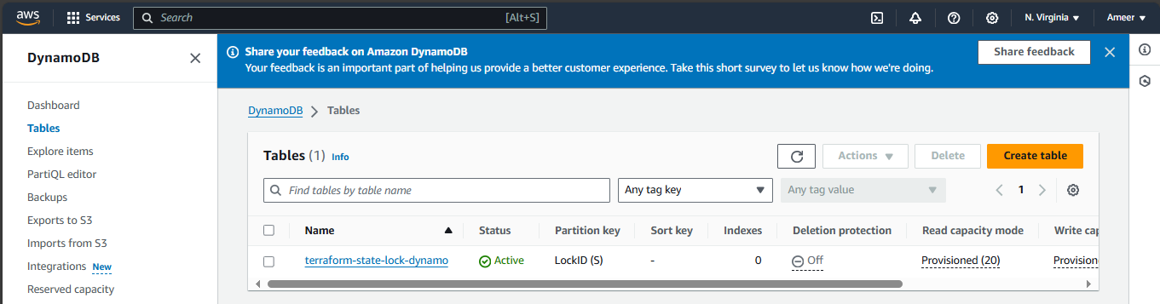

S3 as backend for terraform.tfstate file:

===================================

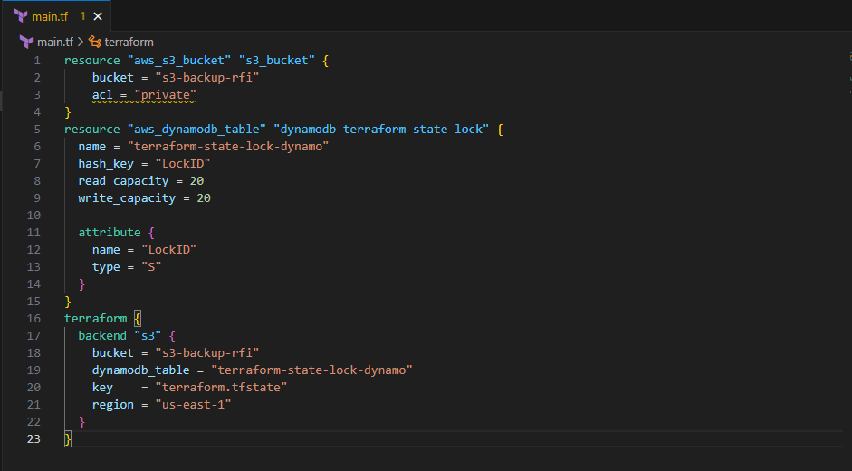

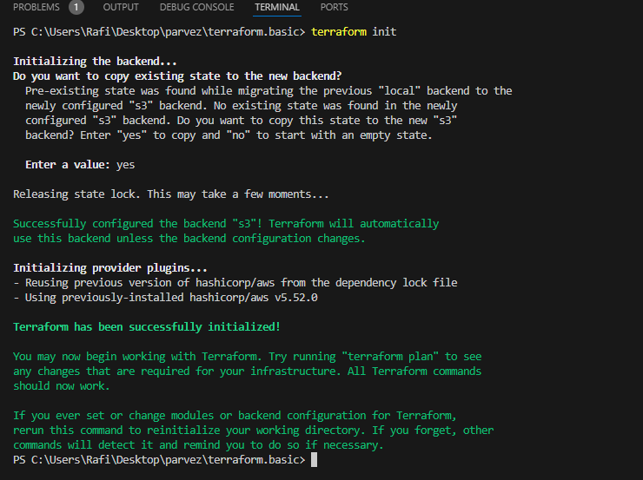

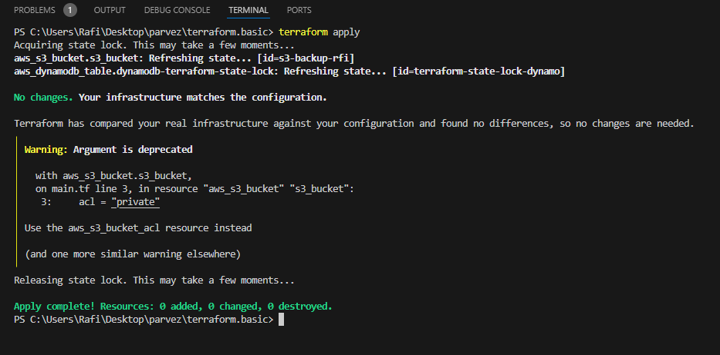

Here state file pushed to S3 service (terraform.tfstate)

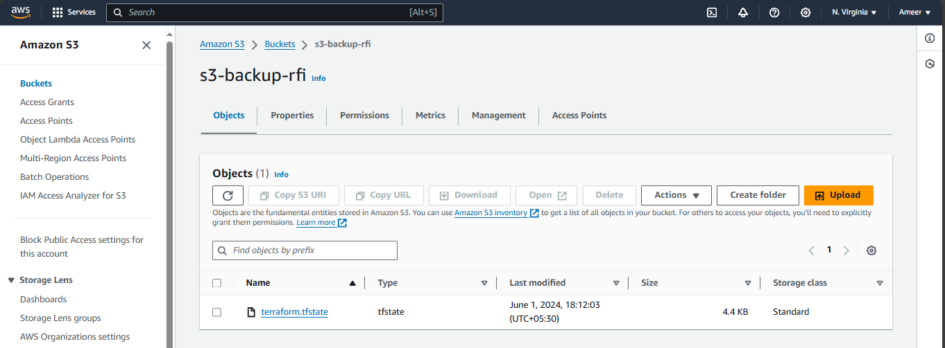

Check Dynamo DB

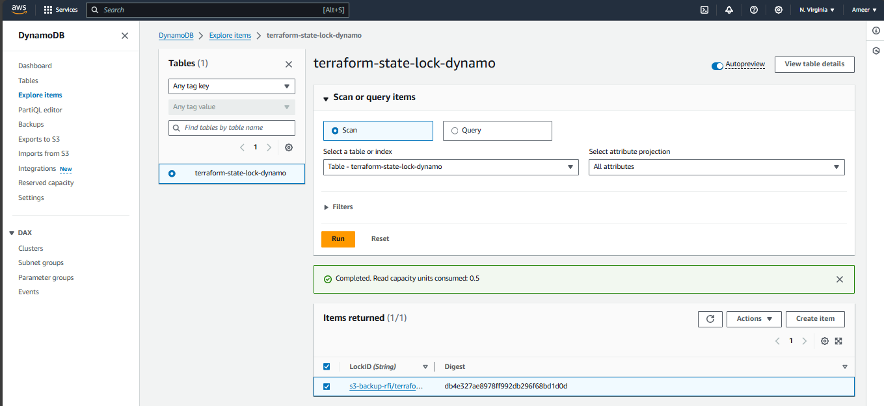

Here Table created in Dynamo DB

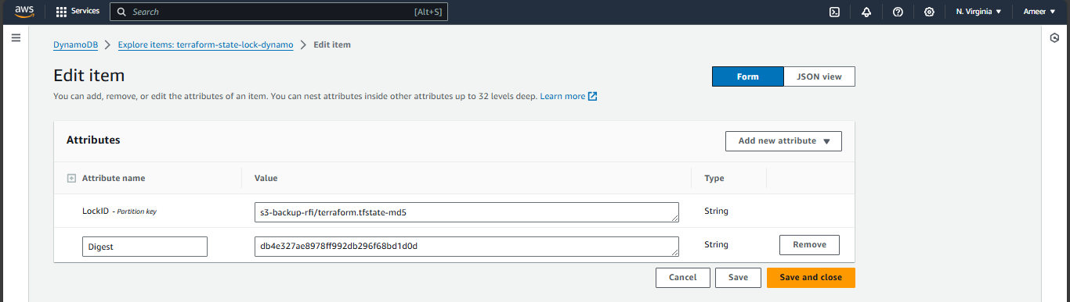

Lock ID displayed

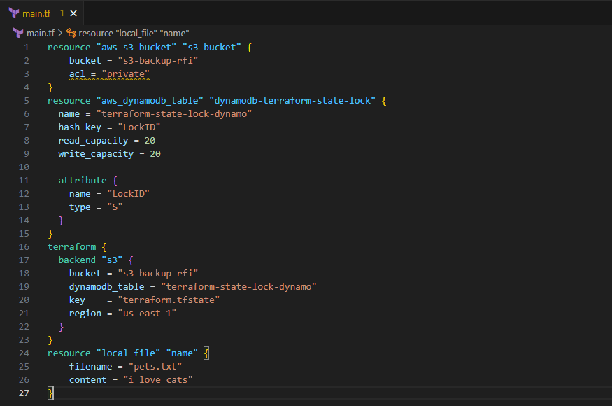

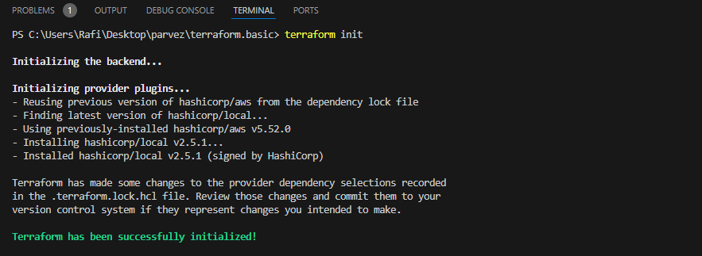

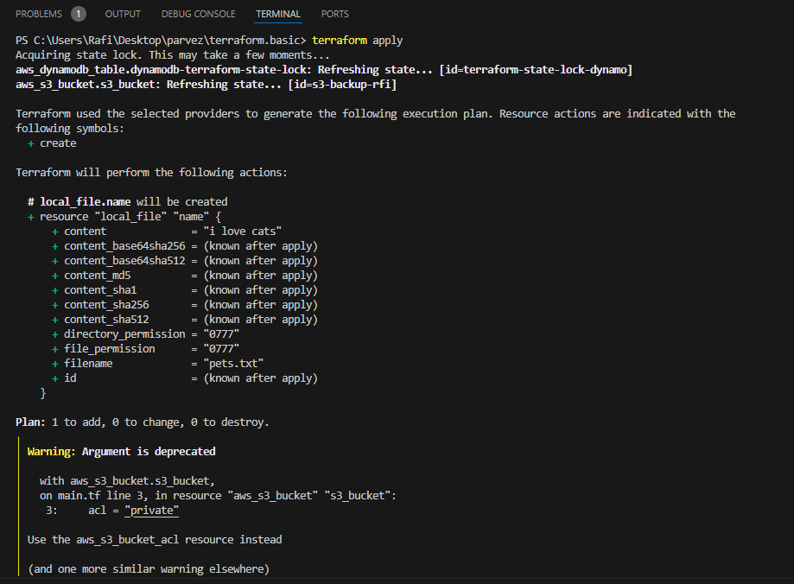

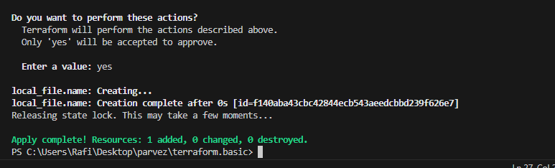

Terraform Provisioners:

=======================

Terraform provisioners allow us to execute command,scripts on remote machines or

local place were terraform is installed.

Provisioners will be written inside the reource blocks.

We have two types of provisioners

1) Remote provisioner

This is used to execute commands at the run time on remote machines.

2) Local provisioner

This is used to execute commands at the run time on local machine. (means where terraform is installed)

**Provisioning one ec2 instance**

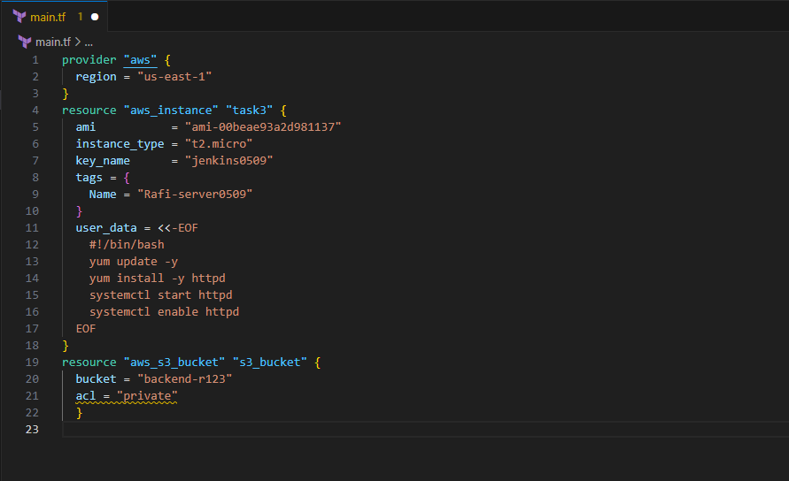

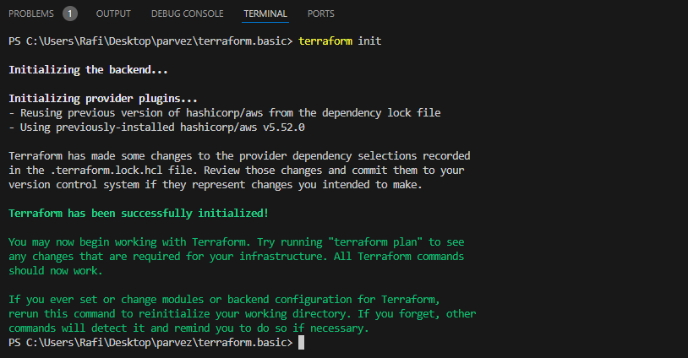

Terraform apply

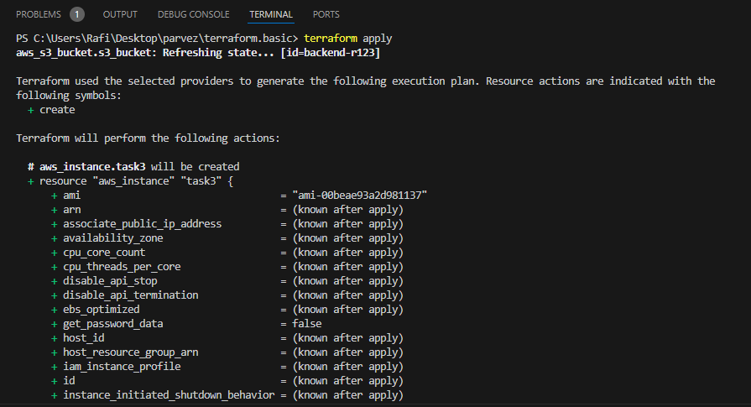

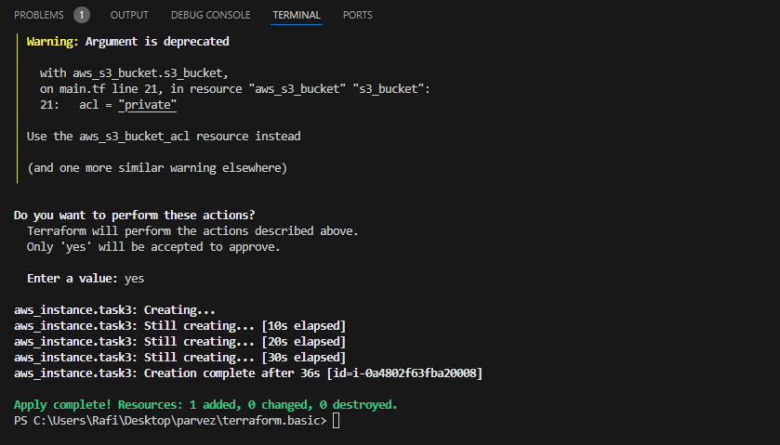

Here created Instance in AWS service

